

INAUGARATION OF THE WALL MAGAZINE
DEPARTMENT OF GEOGRAPHY
DATE: 05.09.2019
VENUE: COMMUNITY HALL, SATABDI BHAWAN

Members Present: Dr. Swapan Kumar Misra (Principal)
Smt. Irani Banerji Chatterjee (HOD)
Sri Mithu Roy
FACULTIES
Sri Somenath Bhuiya
Smt. Rita Pradhan
Sri Sujoy Ghosh
Sri Sanatan Sasmal

The Geography Department of Mugberia Gangadhar Mahavidyalaya arranged a one day ‘Wall Magazine’ Programme in the cultural Hall Room on 5th September, 2019 at 11 am. The whole programme was conducted by the department eager student. Hon’ble Dr. Swapan Kumar Mishra, The Principal of the institution chaired the programme as president. Hon’ble President and the departmental Head, Smt. Irani Chatterjee Banerjee declared the auspicious in anguration through watering the newly planted tree in our college. Besides, Hon’ble Professor Dr. Bidhan Samanta, Dr. Prasanjit Ghose, Prof. Mithu Roy, Somnath Bhunia, Sujoy Das, Sanatan Sasmal, and Rita Pradhan were also present in that observation. The principal of the institution, Dr. Mishra delivered his valuable speech on the importance of wall Magazine. 68 students participated in this programme. The topic of the magazine was WATER WATER EVERYWHERE, NOT A DROP TO DRINK. The main theme of the magazine was the water problem occurring all around the globe. The program reflected how the aforesaid problem concerns students and how they pen it down. The students, alongside their writings, reflected several approaches to the water problem while explaining its cause and effect Principal sir.
the wall magazine secretary was Alik Paria of Sem V. The magazine was designed by Soumita Mondal, and was helped by Dipali Giri, Moumita Gole, Chanchal Giri, Trisha Maity, Anupam Shonbigrohi. Besides, Sanjib Chanda, Sritama Maity and the students of sem V were all involved in organizing the program. Alik presented the crux of the theme to Principal Sir. Prof. Dr. Samanta delivered his speech on the important of the ‘Wall Magazine’. Moreover, Dept. Head, Prof. Irani Banerji Chatterjee delivered her valuable speech on the wall Magazine and inspired the all student to achive more knowledge about this. Then, the student of the institution participated in cultural programme to mark the day. Last of all, the president of the programme declared the end of the ceremony with a vote of marks and with a pledge to arrange more such ceremonies in future.

The magazine:
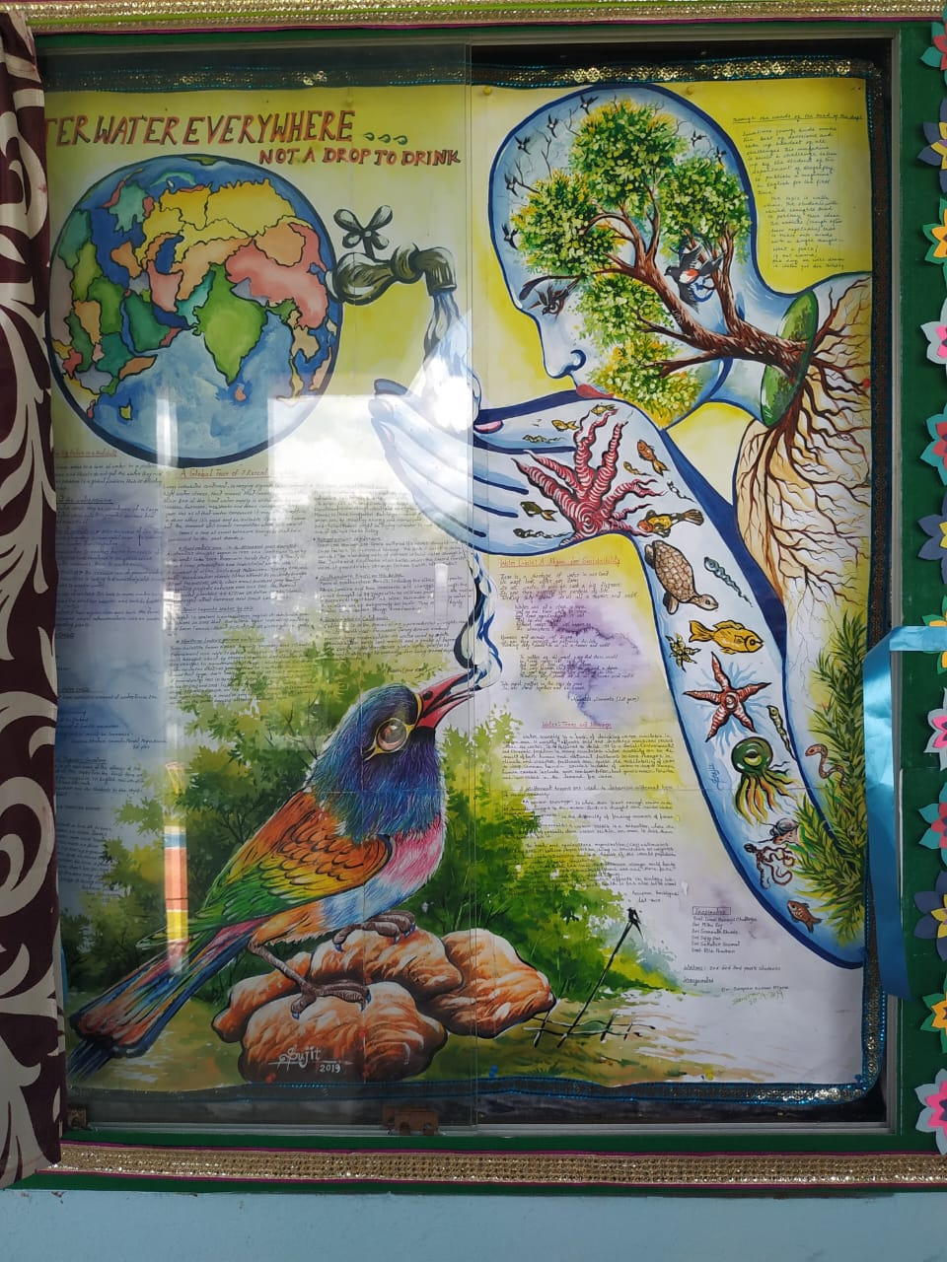

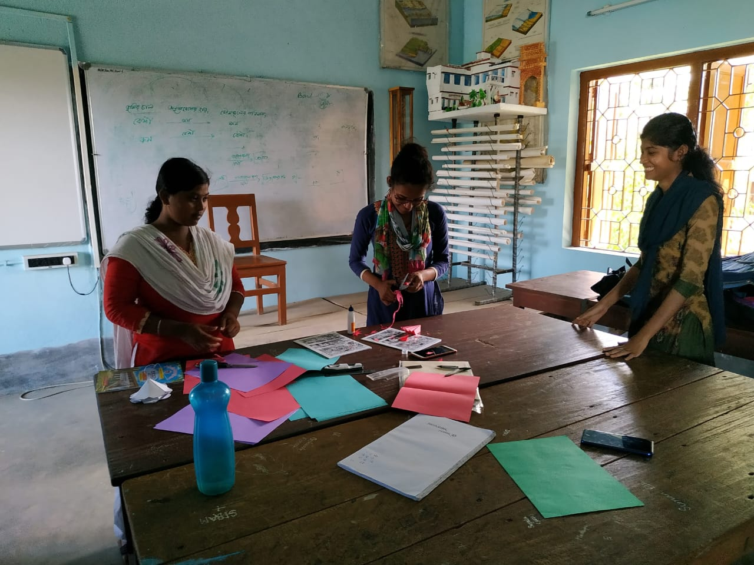
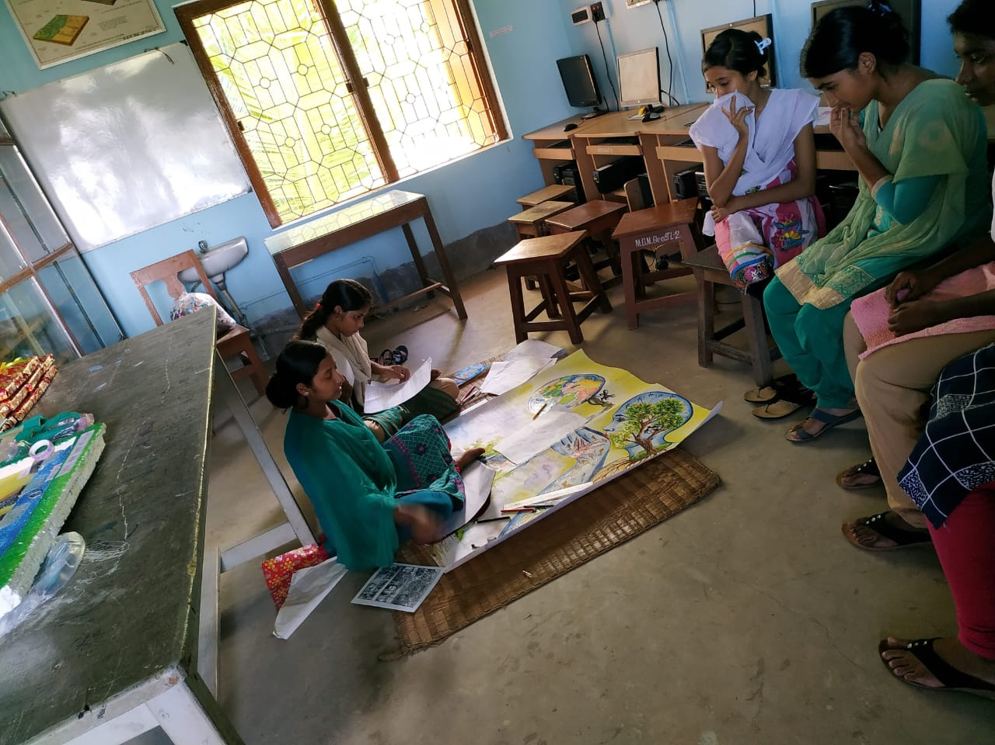

The preparation of wall magazine
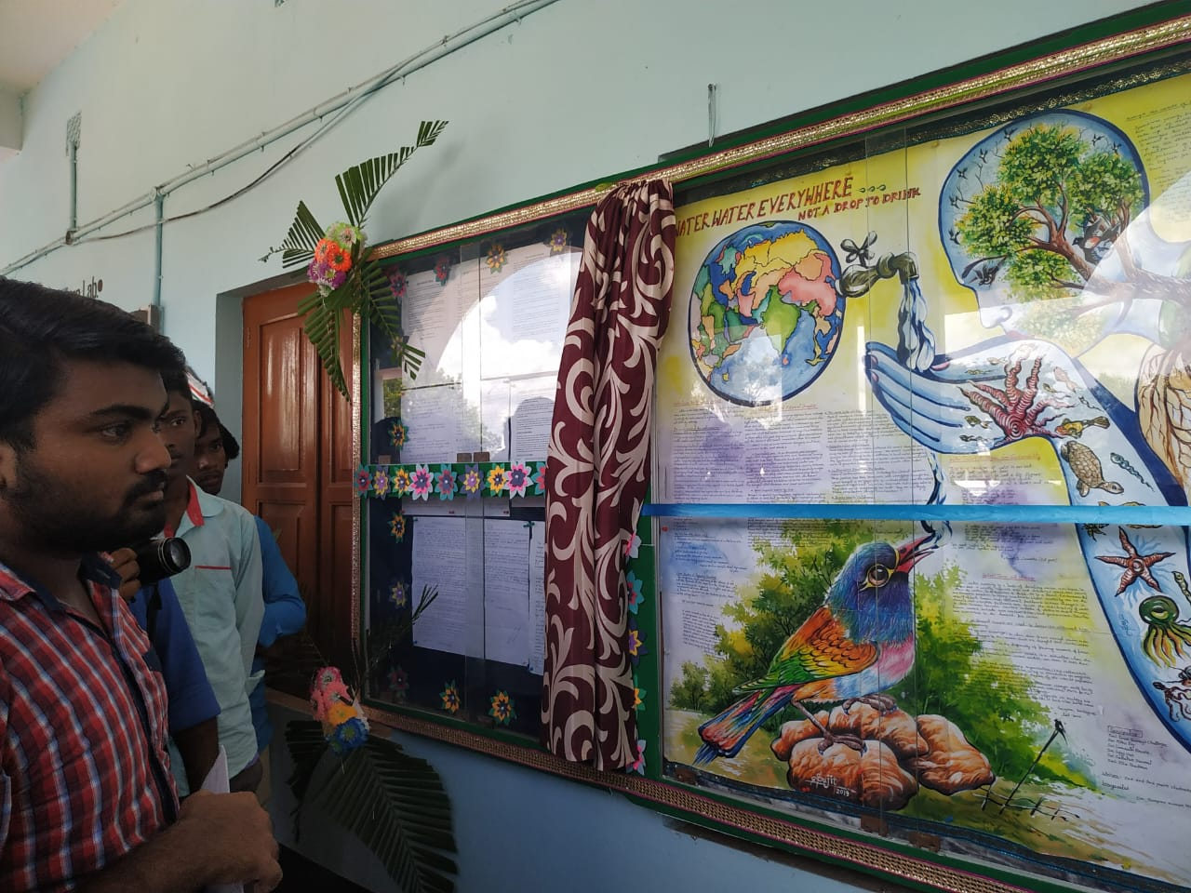
The magazine secretary presenting

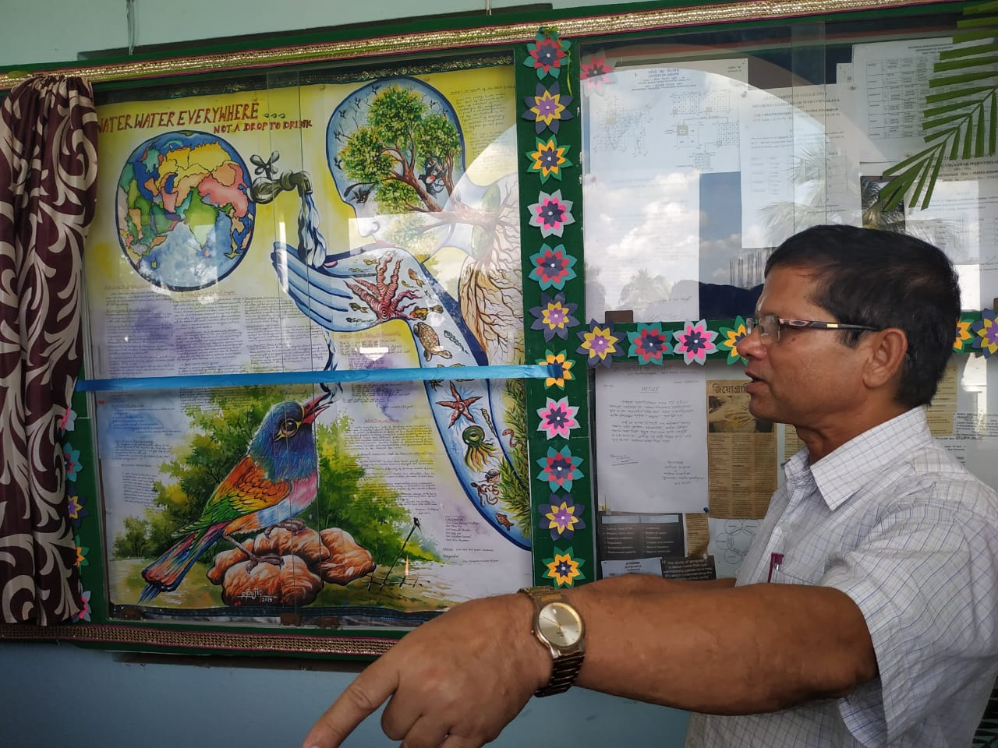

Principal Sir asking details about the topic.

